****1. Introduction****  
Plasma Pen is newest machine that harnesses the power of plasma, a fourth state matter (Solid, Liquid, Gas, Plasma), to help reduce or eliminate certain skin conditions and concerns, such as wrinkles, fine lines, moles, skin tags, etc.Korea plamere plasma pen Through the process of ionization, our unit is able to create an electric charge, or ARC. This arc is focused on a target on the surface of the skin, which causes a controlled burn, which dissipates heat throughout the area being targeted. This technique causes the elimination of moles, skin tags and pigmentation, etc. Moreover, the dissipation of heat throughout the skin being targeted causes your body to send fibroblasts to the area and lay down collagen and elastin fibers, which promotes plumping and tightening of the skin.  
  
****2. Functions****  
It is used for a wide variety of cosmetic procedures, it’s not limited to but comprises of:  
* Non-Surgical Upper Eyelid Lift (Blepharoplasty)  
* Non-Surgical lower Eyelid Tightening  
* Removing Lip Lines  
* Removal of wrinkles  
* Reducing Sun Spots And Pigmentation  
* Tightening Of Loose Skin  
* Non-Invasive Lifting Of Neck (Turkey Neck)  
* Tightening Jaw Line

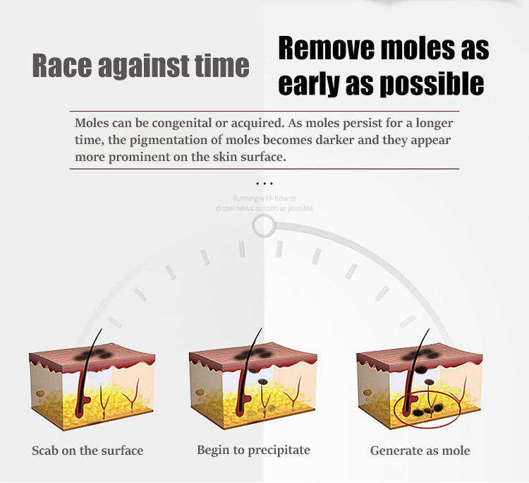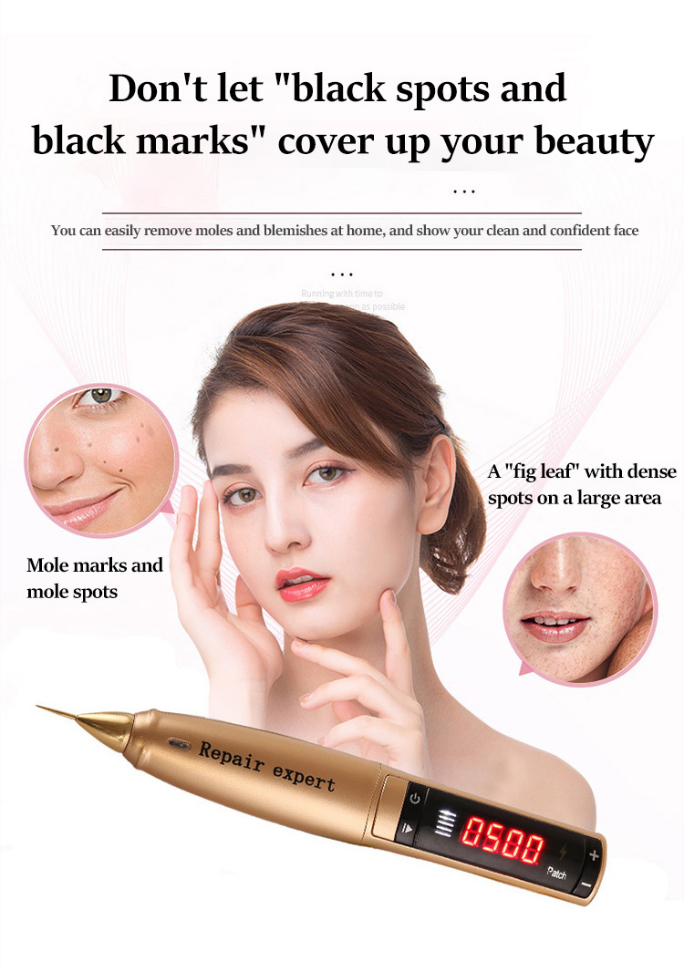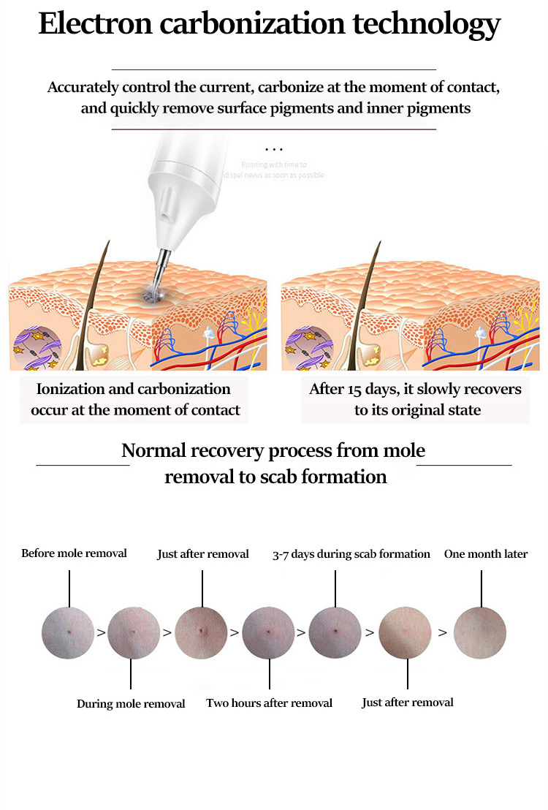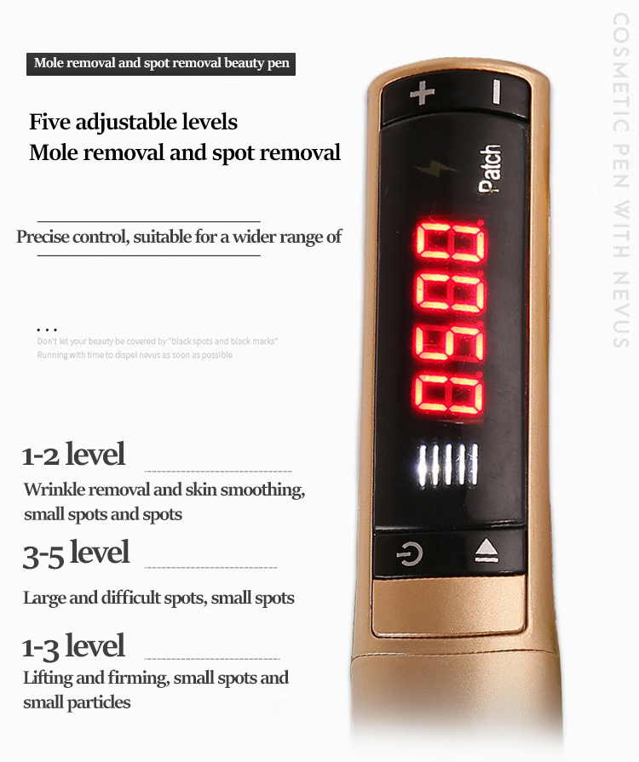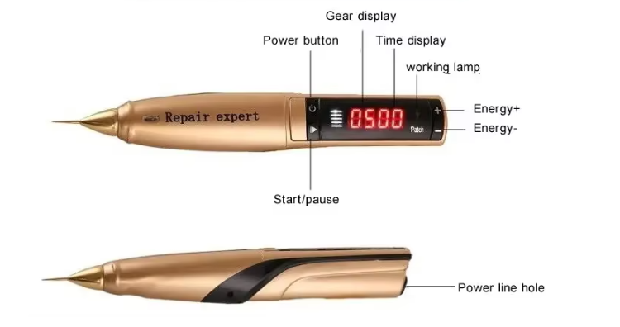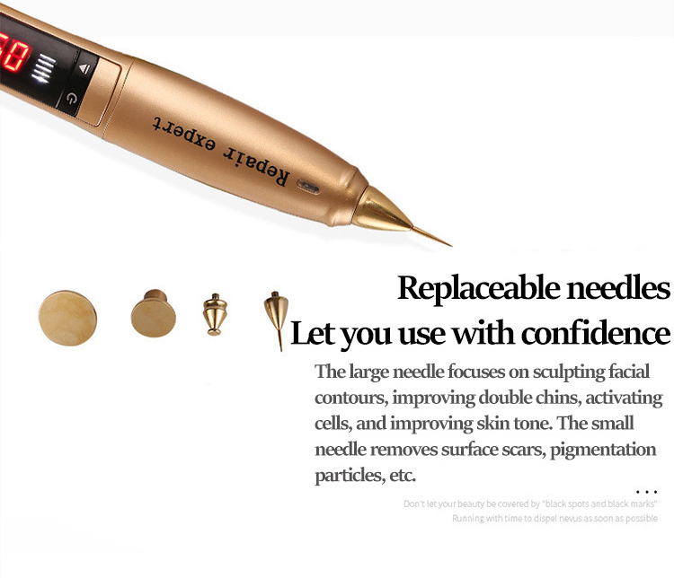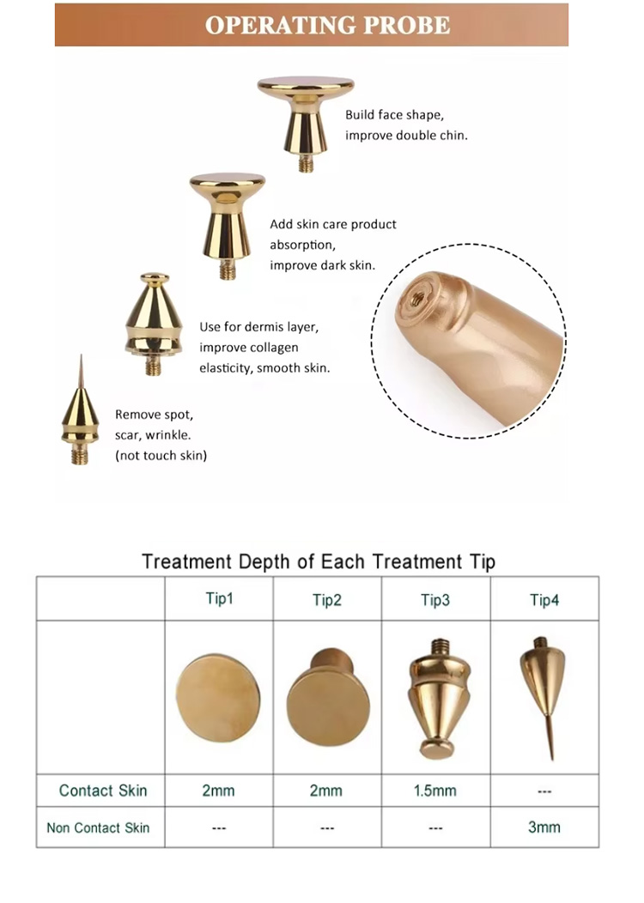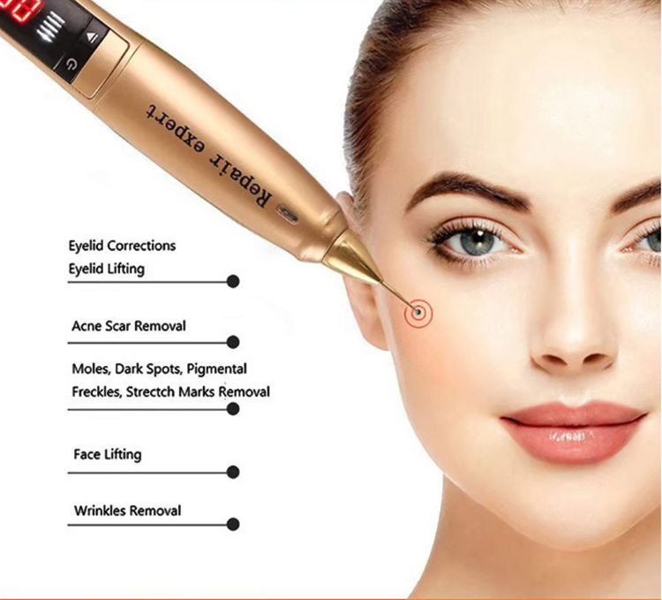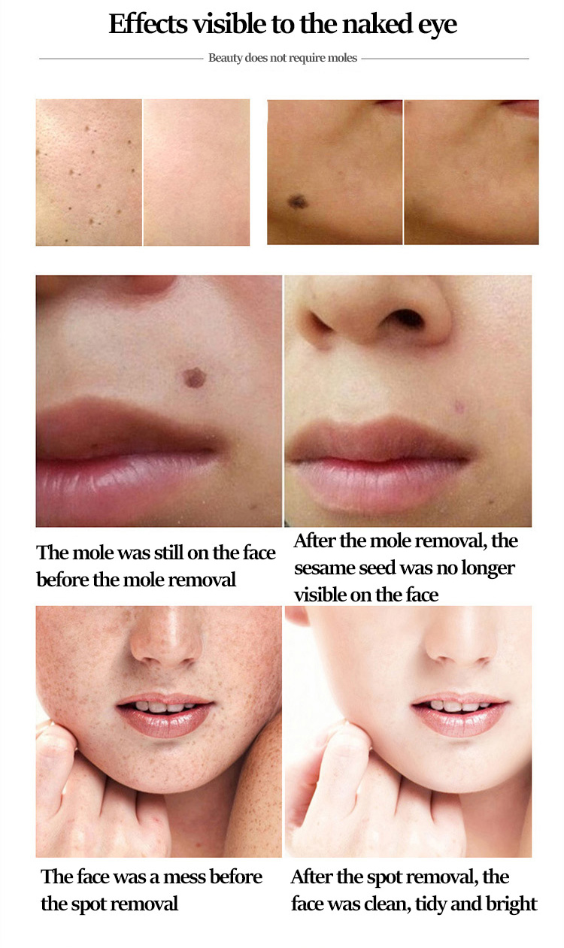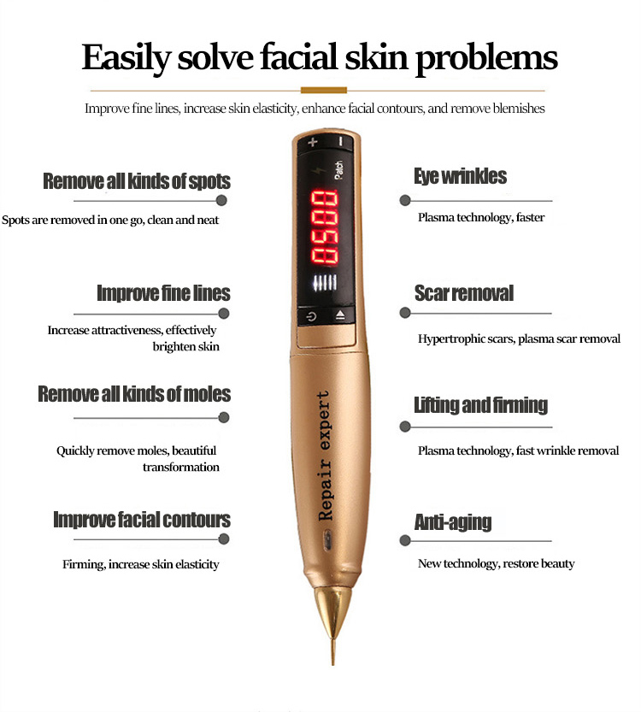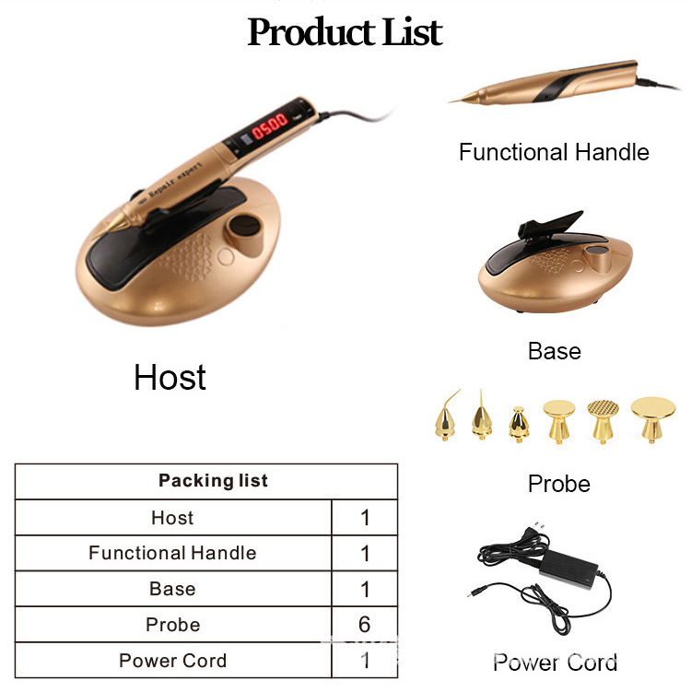

**Company Information**